Roseglen United Methodist Church 717-834-6411 CCLI #795905

Pastor Chris Nauta – cnauta@susumc.org or nauta@mindspring.com
Pastor Cell # – 570-529-3466 & Home Phone 717- 904-2121 RCNS 717-904-2310
Pastor Chris’ Office Hours – Tuesday and Thursday 9AM – 12PM
Church Accompanist – Dirk Shaak Church Secretary – Mary Nelson
roseglenumc@ptd.net Office Hours – Tues./Thurs. 8AM-1PM
Church Website – www.roseglenumc.org

WELCOME!
We extend a most cordial welcome to all guests who are worshipping with us this morning. We hope that this service provides an opportunity for you to become closer to God. Please complete the “Connection” Card and place it in the offering plate, so we can serve you better. Let us know if there is anything we can do for you. We’re glad you came.
OUR VISION
We, the fellowship of believers at Roseglen United Methodist Church,
are committed to: receiving all persons with open arms; nurturing one another to grow spiritually in the love of Christ; and serving the community through
our relationship with God; while living our lives as a n example of
God’s word and defending God’s creation.

THA NK YOU TO OUR WORSHIP HELPERS!

THIS WEEK’S HELPERS NEXT WEEK’S HELPERS

Worship Leader: Pastor Chris Worship Leader: Pastor Chris
Acolyte: Claire Finkenbinder Acolyte: Reed Finkenbinder
Children’s Chat: Children’s Chat: Dirk Shaak
Greeters/Ushers: Ken & Treva. Greeters/Ushers: Larry & Abby

October 27, 2019 Attendance 85 – Sunday School 20
Offering Envelopes $ 1,478.00
Sunday School Offering $ ------
Building & Growth Offering $ 50.00
Loose Offering $ 202.00
TOTAL $ 1,730.00

Weekly Giving Needed to Meet Budget 2019: $ 1,755.00
Basket Brigade – OCC ShoeBox Postage $ 99.00

ROSEGLEN October Income/Expenses (approximate)

Income Expense

Envelopes $ 5,669.00 Pastor & Utilities $ 1,705.00
Loose Offering $ 597.00 Secretary & Accompanist + SS $ 1,060.00
Sunday School/Bible Study $ ------ SS Exp./Family Min./Worship $ 282.00
Basket Collection/Mission $ 266.00 Utilities /Water $ 1,038.00
Building & Growth $ 200.00 Copier/Ofs. Supplies $ 144.00
Misc. Income $ 10.00 Child. Chat Mission .. $ 460.00 Confer. Support/Insurance $ 1,042.00
TOTAL INCOME $ 6,742.00 TOTAL EXPENSES $ 5,731.00

PLEASE NOTE: If you are the last one to use the church nursery or basement, please make sure that the temperature is adjusted properly, THANK YOU!
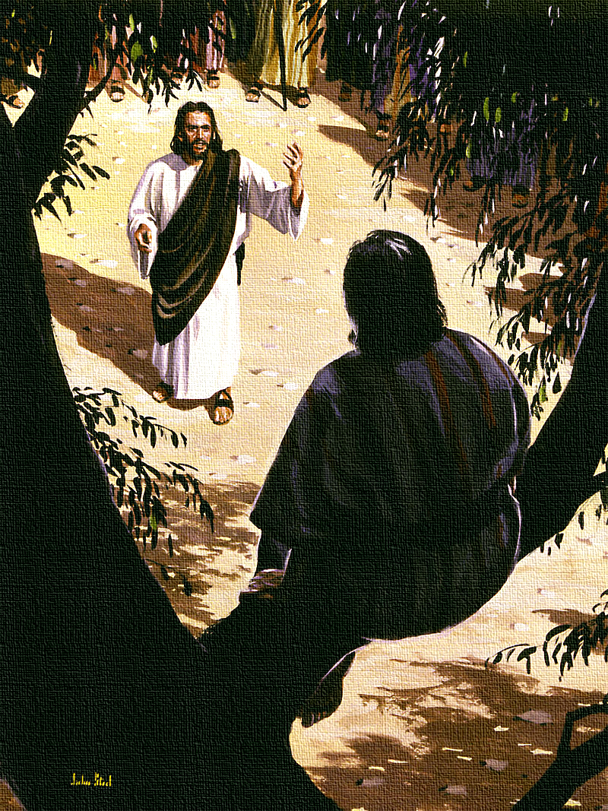

The Least the Last, and the Lost…

ROSEGLEN United Methodist Church

November 3, 2019 Communion/All Saints’ 10:00AM Worship

ANNOUNCEMENTS

GOD IS GOOD ALL THE TIME! ALL THE TIME! GOD IS GOOD!

PRAISE HYMN - #2022 “Great is the Lord” Insert
*GREETING – The Lord be with you!
And also with you
The righteousness of God is everlasting;
The law of God is truth.
God’s decrees are righteous forever;
We delight in the commandments of God.

*HYMN - #451 “Be Thou My Vision”

SHARING OF JOYS AND CONCERNS

Prayers of the People, sILENT PRAYER

APOSTLE’S CREED #881 Traditional Version

I believe in God, the Father Almighty, maker of heaven and earth;

And in Jesus Christ his only Son, our Lord; who was conceived by
The Holy Spirit, born of the Virgin Mary, suffered under Pontius Pilate,
was crucified, dead, and buried; the third day he rose from the dead;
He ascended into heaven, and sitteth at the right hand of God the Father
Almighty; from thence he shall come to judge the quick and the dead.

I believe in the Holy Spirit, the holy catholic Church,
The communion of saints, the forgiveness of sins,
The resurrection of the body, and the life everlasting. Amen.

ALL SAINTS’ DAY REMEMBRANCE

PRAYER OF CONFESSION Page 890

SACRAMENT OF HOLY COMMUNION Page 15

CHILDREN’S CHAT –

BASKET BRIGADE – Today’s the basket brigade will continue collecting for Operation Christmas Child Shoebox postage. Thank you!

We HEAR GOD’S WORD READ AND PROclaimed

SCRIPTURE READINGS – Scripture Reading – Habakkuk 1:1-4
Epistle – 2 Thessalonians 1:1-14, 11-12
*GLORIA PATRI - #70

*GOSPEL READING – Luke 19:1-10

SERMON – “The Least, the Last, and the Lost”

We Respond in Praise and Thanksgiving

OFFERING (Place your completed “Connection Card” in the Offering Plate.).

*DOXOLOGY - #95

Praise God, from whom all blessings flow;
Praise Him, all creatures here below;
Praise Him above, ye heavenly host;
Praise Father, Son, and Holy Ghost. AMEN.

PRAYER OF THANKSGIVING

*CLOSING HYMN - #383 “This Is a Day of New Beginnings”

*COMMISSION & BLESSING –

Carrying the Light of Christ into the World.

We Go Into the World to Serve and Love God

*Please stand as you are able.

Making Disciples of Jesus Christ for the
Transformation of the World.

WEEKLY CALENDAR OF EVENTS

SUNDAY, November 3rd

9:00AM – Adult & Youth Sunday School
10:00AM - Worship Service
Children’s Sunday School during the Worship Service

CHILDREN’S SUNDAY SCHOOL CLASSES – November

November 03: Stepping Stones Amber Finkenbinder
Faith Weavers Betsy Strayer (Combined Bells)
November 10: Stepping Stones Grant Finkenbinder
Faith Weavers Joan Wilson

NEXT WEEKS WORSHIP INFO: November 10th Green
SCRIPTURE: Isaiah 65:17-25, 2 Thessalonians 3:6-13, Luke 21:5-19
SERMON: “Hope, Hope and ALWAYS”

Your Prayers are Needed!

Hebron UMC 11/03 – Darlene Foose & family 11/03 – Coworker battling cancer 11/03
Candice & kids, John & Kelly, Bill & Kendra, and my foot for quick recovery 11/03
Eunice, lung cancer 10/20 - Friends & Family, a difficult time 10/20 – Jim, Donna’s Brother
Aunt Dot, mass 10/20 – Cole Spidle, stationed in Afganistan 10/20 – Dick 10/20
Pr. Dennis & Mt. Gilead, leukemia 10/20 - Lucy 10/13 – Mick & Jackie 10/13
Dirk’s brother Jim, health issues 10/06 - Coworkers 2nd battle with cancer 10/13

JOYS
Grant & Judean had a baby boy, Silas (7lbs 12oz 20”) 11/03 – Rhonda & Dirk, 2nd great grandson, Holden Bauer 11/03– Treva’s birthday 11/03 – Rainbow 11/03 – Hawk Rock climb Timothy’s 13th birthday 11/03

NOTE: Prayer requests will be listed for 4 weeks, Joys for 2. If you would like your requests to remain on the list longer, please resubmit them. THANK YOU!

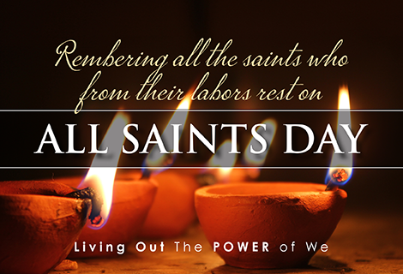

CONFERENCE “Circle of Prayer”
The names of this week’s churches are listed below. Please pray for them.

November 03 – November 09

Tunkhannock UMC, Tunkhannock Watts Memorial UMC, Belleville
Bethlehem Stonepile UMC, Red Lion Allemansville UMC, Fallentimber
Town Hill UMC, Shickshinny Palestine UMC, Morrisdale
Balls Mills UMC, Cogan Station Aldersgate UMC, Mechanicsburg
Wenksville UMC, Biglerville First UMC, Catawissa
Port Loko UMC, Port Loko - Sierra Leone

RCNS & RUMC Food Drive for Perry County Food Bank
Please donate any amount of food, and use the bags provided or your own, to bring the items to church. The food bank is looking for donations of food staples for the holidays and specifically could use any of the following:
cranberry sauce instant potatoes pie filling Bisquick
canned pasta cans of veggies cake mixes, frosting canned fruit
instant pudding cans of pumpkin stove top stuffing brownie mix
cans or jars of gravy applesauce peanut butter
PLEASE BRING IN DONATIONS by NEXT Sunday, November 10th. The food bank truck will come on Wednesday, Nov. 13th. Pastor Chris will bless the food and the families and then students will help fill the truck!

Your Prayers are Needed!

Hebron UMC 11/03 – Darlene Foose & family 11/03 – Coworker battling cancer 11/03
Candice & kids, John & Kelly, Bill & Kendra, and my foot for quick recovery 11/03
Eunice, lung cancer 10/20 - Friends & Family, a difficult time 10/20 – Jim, Donna’s Brother
Aunt Dot, mass 10/20 – Cole Spidle, stationed in Afganistan 10/20 – Dick 10/20
Pr. Dennis & Mt. Gilead, leukemia 10/20 - Lucy 10/13 – Mick & Jackie 10/13
Dirk’s brother Jim, health issues 10/06 - Coworkers 2nd battle with cancer 10/13

JOYS
Grant & Judean had a baby boy, Silas (7lbs 12oz 20”) 11/03 – Rhonda & Dirk, 2nd great grandson, Holden Bauer 11/03– Treva’s birthday 11/03 – Rainbow 11/03 – Hawk Rock climb Timothy’s 13th birthday 11/03

NOTE: Prayer requests will be listed for 4 weeks, Joys for 2. If you would like your requests to remain on the list longer, please resubmit them. THANK YOU!

CONFERENCE “Circle of Prayer”
The names of this week’s churches are listed below. Please pray for them.

November 03 – November 09

Tunkhannock UMC, Tunkhannock Watts Memorial UMC, Belleville
Bethlehem Stonepile UMC, Red Lion Allemansville UMC, Fallentimber
Town Hill UMC, Shickshinny Palestine UMC, Morrisdale
Balls Mills UMC, Cogan Station Aldersgate UMC, Mechanicsburg
Wenksville UMC, Biglerville First UMC, Catawissa
Port Loko UMC, Port Loko - Sierra Leone

RCNS & RUMC Food Drive for Perry County Food Bank
Please donate any amount of food, and use the bags provided or your own, to bring the items to church. The food bank is looking for donations of food staples for the holidays and specifically could use any of the following:
cranberry sauce instant potatoes pie filling Bisquick
canned pasta cans of veggies cake mixes, frosting canned fruit
instant pudding cans of pumpkin stove top stuffing brownie mix
cans or jars of gravy applesauce peanut butter
PLEASE BRING IN DONATIONS by NEXT Sunday, November 10th. The food bank truck will come on Wednesday, Nov. 13th. Pastor Chris will bless the food and the families and then students will help fill the truck!
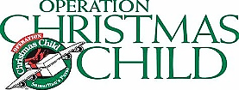
OCC SHOEBOXES are available. They are located in the back of the church. Please return the filled shoeboxes by Next Sun., November 10th. Thank you!

OCC SHOEBOXES are available. They are located in the back of the church. Please return the filled shoeboxes by Next Sun., November 10th. Thank you!

